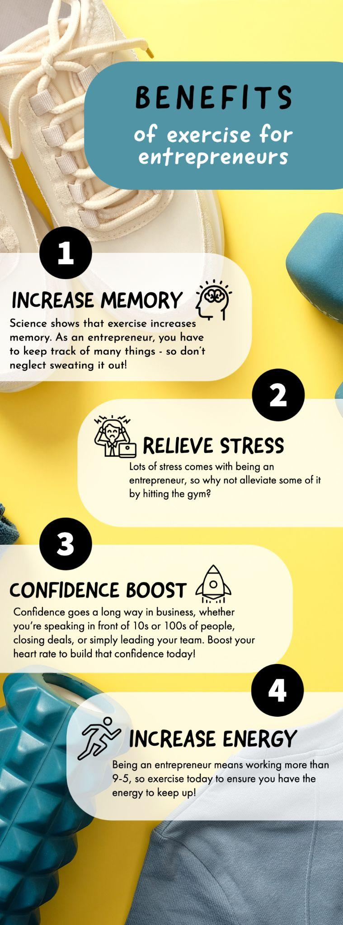

Top Benefits of Exercise for Budding Entrepreneurs
We all know that exercise is good for our health. But did you know that it can also have a positive impact on your business? That's right—being physically active can actually make you a better entrepreneur. Here's how.

Increases Energy:
We all know that feeling of being sluggish and tired after sitting at a desk all day. But did you know that exercise can actually help increase your energy levels? When you work out, your body releases endorphins, which have been shown to boost mood and increase alertness. So if you're looking for a natural way to fight fatigue, regular exercise just might be the answer.

Boosts Self-Esteem:
As an entrepreneur, it's important to have confidence in yourself and your abilities. And what better way to boost your self-esteem than by getting in shape? When you feel good about your physical appearance, it'll show in your attitude and the way you carry yourself—two things that can make a big impression on potential clients or investors.

Improves Immunity:
Let's face it, running a business is stressful. And when we're stressed, our bodies are more susceptible to illness. That's why it's important to do everything you can to keep your immune system strong. Exercise has been shown to improve immunity by increasing the production of white blood cells, which help fight off infection. So if you want to stay healthy and avoid getting sick days, regular exercise should be part of your game plan.

Improves Concentration:
It's no secret that entrepreneurs need to be able to focus in order to be successful. If you're finding it hard to stay concentrated, though, regular exercise may be able to help. Studies have shown that moderate aerobic activity can improve cognitive function and increase task persistence. So if you're struggling with concentration, a little bit of exercise may be just what the doctor ordered.

Inspires Others to Start Their Own Businesses:
Being fit isn't just about looking good; it's also about feeling good. And when you feel good, you're more likely to be motivated and inspired. That's why so many successful entrepreneurs credit their success to their fitness routines. After all, being fit requires dedication, discipline, and a positive attitude—all qualities that are essential for any business owner. It's no coincidence that so many successful people make time for a workout each day; they know that it gives them the energy and focus they need to tackle whatever challenges their business might face. So if you're thinking of starting your own business, don't underestimate the importance of staying fit. It just might give you the extra edge you need to succeed. If you’re not sure where to start, this guide on how to start an LLC will point you in the right direction to making your entrepreneurial dreams a reality.

Working Exercise Into a Busy Schedule:
Being an entrepreneur is all about being busy. There always seems to be another meeting to attend, another client to meet, or another problem to solve. However, it is important to find time for exercise, even if it means getting up a little earlier or working out during lunch. Exercise provides many benefits, including increased energy levels, improved mental focus, and reduced stress levels. In addition, regular physical activity can help to reduce the risk of developing health problems such as obesity, heart disease, and type 2 diabetes. While it may be tempting to skip a workout when time is tight, remember that exercise can actually save you time in the long run by helping you to stay healthy and productive.

As an entrepreneur, it's important to take care of yourself both physically and mentally. Exercise does both by providing numerous benefits that can help you in both your personal and professional life. From improving self-esteem and concentration to inspiring others and boosting energy levels, there's no reason not to make exercise part of your daily routine. So get up and get moving—your business will thank you for it!

Not sure where to start on your fitness journey? Take a class at The Body Workshop!

